Reunion Update!
Our plans for the Reunion are coming together! On September 6, 7 and 8 we will rock the best party in 50 years!
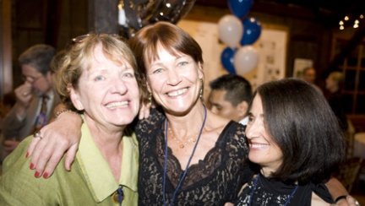
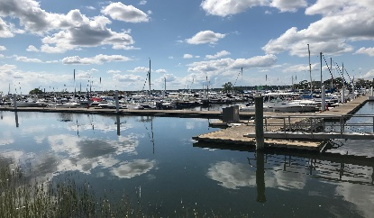
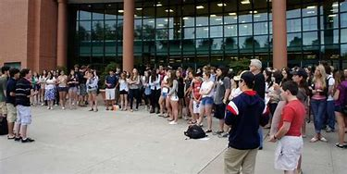
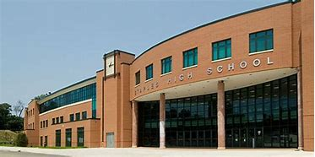
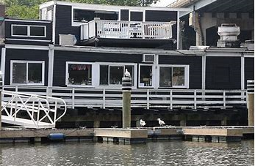
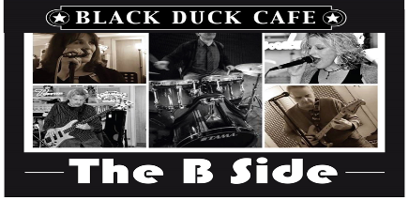
On Friday Night it’s “Woodstock at the Duck.” We have worked with the Duck’s owner, Pete Atkins, and lined up a band that can deliver the Woodstock tunes we love: The B-Side Band really rocks! Check it out: https://theb-sideband.com/live-video. Get there by 6-ish to mingle before the band revs up at 9 pm. Admission is free for 69-ers.
On Saturday, at 11 am, we’ve arranged for a Tour of Staples. Our host is Assistant Principal Richard Franzis and our Guides will be Staples Student Ambassadors. The Tour will take about 2 hours because there’s A LOT to see: http://www.mendelssohnchoir.com/images/Maps/shs_map.gif
You’re on your own Saturday afternoon. Cruise Main Street, drive by your old house, have lunch in one of Westport’s great restaurants.
Saturday evening is the Reunion Party at the Minuteman Yacht Club at Compo Beach. We’ll start with cocktails and nibbles at 4 pm on the porch overlooking the Marina. High tide is 6:13, sunset is 7:19, so it’ll be beautiful! Then the grills will be fired up and we’ll serve Surf & Turf Dinner at 6:30. We have great caterer lined up and we have decided to have an open bar! For directions/info: https://minutemanyc.com/
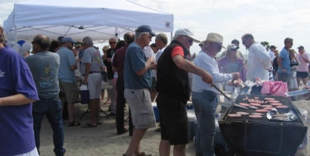
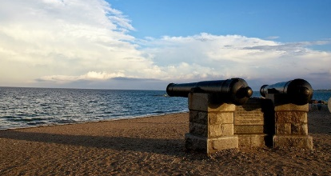
On Sunday we have “Brunch on the Beach,” at 10 am. You’ll see our tents by the cannons, where Chef Alex Shook will have a wonderful brunch ready for you. Bring your kids and grandkids for a relaxing morning.
How much does all this cost? $125 per person, plus any donation you can give for our Class Gift to the Staples Tuition Fund.

